Everything you need to know about Bobbin Cases

Supplies needed:

Bobbin Case cleaner or business card

Canned Air or Compressed air

Magnetic Bobbin

Bobbin case

[Bill Gavin’s Intro Video](https://vimeo.com/250221769)

[Bobbin Tension Drop Test](https://youtu.be/OD3on88gFag)

[Adjusting Bobbin Case Tension](https://youtu.be/j7L9R22FuNw)

We use Magnetic Filament Bobbins in black or white thread.

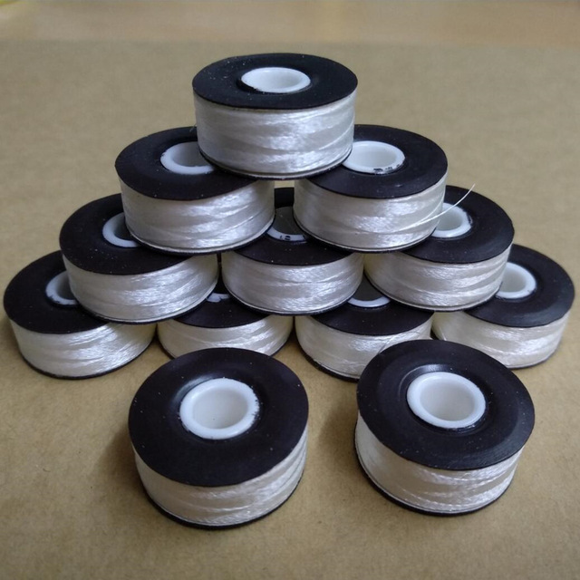

You should choose a bobbin thread that will compliment the thread colors of the embroidery as well as match the inside of the garment. So if a design is all white or all black, match the bobbin to the thread. If its multicolored, then match the bobbin to the garment. If you are ever not sure, default to white.

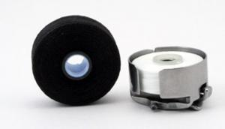

The magnet side should always go face down into the bobbin case. If you can see the magnet, its in wrong.

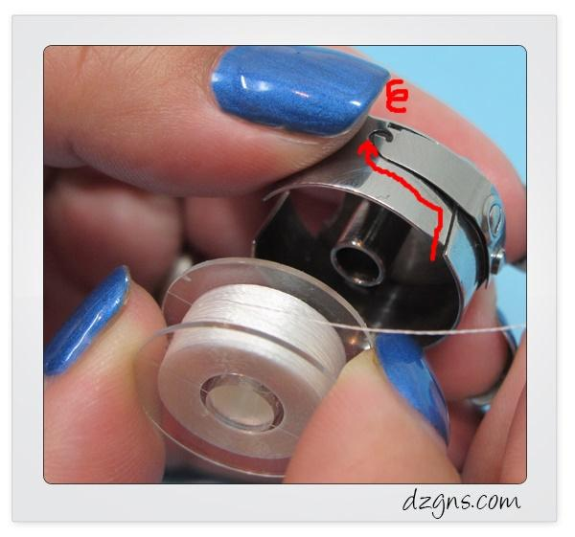

Insert the bobbin into the bobbin case and pull the thread through the slit and under the arm that adds tension. This is the moment you will do a drop test to make sure no adjustments are needed to the big screw.

**If you are getting birdsnests, Check your bobbin tension. That is a signal that the bobbin is so tight that its pulling the thread from the top of the design down into the bobbin case!**

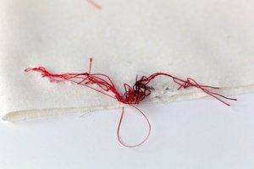

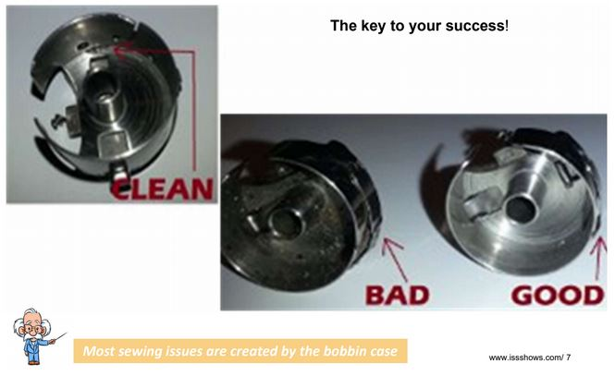

**You cannot do a drop test if the bobbin case is dirty.** Clean it out with compress air every time you change a bobbin. It will affect the tension!

If the bobbin case no longer adds tension to the thread - replace it. If the pigtail is missing, replace it. If you dropped it, alert manager to which head its in. Dropping might damage it beyond repair and cause the bobbin to not spin evenly inside it.

If the bobbin won't spin evenly (jerky spinning motion), try the bobbin in another bobbin case. If it works fine, the bobbin is ok and the bobbin case needs to be replaced. If it’s jerky in the other bobbin case, it might be a bad bobbin!

We use filament polyester thread because it gives off less lint then a spun thread bobbin.

Changing the bobbin (make video):

When your bobbin runs out, the machine will give you an upper thread break message. When you check and see that the thread is indeed still connected, run your hand under the embroidery hoop and if the bobbin has run out - you will not feel the thread. Another clue is you might see the bobbin thread poking up through the embroidery. You should pull the bobbin thread tight and clip this tail so it doesn’t show on the product.

1. Replace the bobbin by removing the bobbin case. If the garment doesn’t let you reach it, its ok to remove the hoop from the frame.
2. Remove the old bobbin (its only the magnet and core). (Picture) If you are using a multihead machine, plan on stopping at the end of this round and repeating these steps for all the other heads (their bobbins are almost out too, it saves time to change all the bobbins at once!)
3. With compressed air, spray out the rotary case arm and bobbin case.
4. Oil the rotary hook.

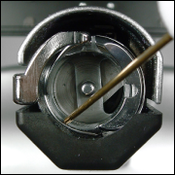

1. Put new bobbin in bobbin case and insert back into the machine.

If you ever take a bobbin case out and it is **warm** you need to OIL THE ROTARY HOOK! The bobbin is warm because of metal on metal friction from your poor oiling practices.